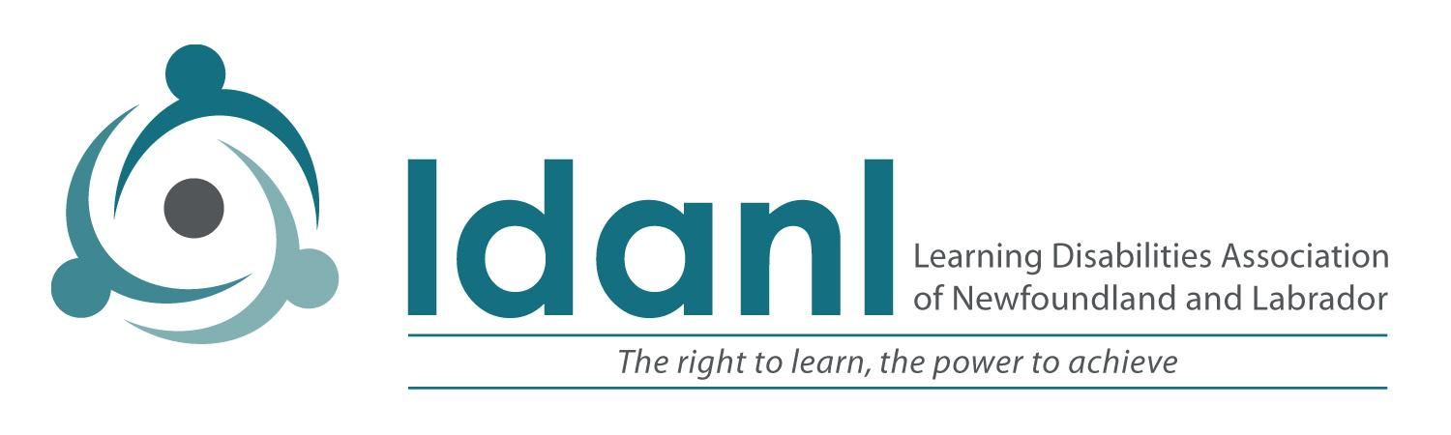

February 5, 2021

Dear Mr. Pelley,
We write to you today representing The Learning Disabilities Association of Newfoundland and Labrador (LDANL). We are reaching out to you and the other party leaders during this election campaign to make you aware of the critical issues and concerns that we hear from parents (on behalf of their children), adults who have Learning Disabilities, as well as educators, health care providers and others in supportive roles. The issues we raise below are made known to us through frequent phone calls, and emails that come to our office, from individual meetings, from Social Media input as well as from a Needs Assessment which we completed in the last two years.
We request your response to our questions and your feedback as to how you will address these issues should your party form the next provincial government and look forward to sharing your reply with our community.

Background
LDANL is a provincial organization that has been supporting persons with Learning Disabilities (such as Dyslexia, Dysgraphia and other LDs) and their families for over 30 years through literacy and math tutoring services, assistive technology services, advocacy, navigation and outreach, workshops, conferences and various other supports. We are now providing virtual services and so can support individuals across the entire province.
Learning Disabilities is by far the largest category of identified exceptionality in the province’s schools and, by extension, the province. Data from the NL Department of Education in 2018-2019, shows that 65.2% of all children with identified “exceptionalities” in schools in 2018-19 were identified with Learning Disabilities. This represented 16.3% of the total student population in the province at that time. This does not include those whose primary disability is ADHD (which co-occurs with LD frequently) as well as those who are not yet assessed/diagnosed. These children grow up to be adults, many of whom continue to struggle with their Learning Disability, which is life-long. Some of these individuals, with effective and timely support, go on to become very successful in their chosen careers. Unfortunately many do not and they often enter our homeless and prison populations, poverty and mental health/addictions systems. We have recently introduced programming for vulnerable and at-risk youth and are collaborating with Her Majesty’s Penitentiary to plan possible intervention. It is our mission to reduce these risk factors and enable those with Learning Disabilities to reach their full potential.

Issues and Concerns
Our community has expressed many concerns and some of these are summarized below.

1. Access to Timely Assessment
Learning Disabilities is one of the only disabilities that relies on school personnel to identify and diagnose. Many/most other disabilities are recognized and diagnosed before the child enters school (e.g., Autism Spectrum Disorder, Down Syndrome, Spina Bifida, Blindness, Deafness, Speech-Language Disorder). By far most of these are diagnosed through our Healthcare System which means that they are covered under MCP. Children with Learning Disabilities depend on the knowledge of teachers and Guidance Counsellors/Psychologists to recognize the indicators and to complete the comprehensive assessment leading to a diagnosis. We strongly believe that early identification and early intervention are vital for our children to succeed, yet we frequently hear that children struggle for years in school without getting assessed. Sadly some never get assessed and some end up in poverty, unemployed or underemployed, with mental health issues or dealing with addictions and the justice system. The problem is multi-faceted: lengthy assessment waitlists for Guidance Counselors, philosophical views that it is better to “wait and see” (which sometimes means “wait and fail”), teachers who are unable to pick up the signs and make referrals, parents keeping their child afloat through exhaustive and costly interventions outside of school. Many parents, frustrated by this, pay the approximate cost of $3500 for an assessment through a private Psychologist. Many of our underprivileged and at-risk families cannot do this, creating a glaring inequity. Early identification and intervention is a far less costly approach than dealing with the complex issues that unidentified needs can result in later in life.
If your party forms the next government, how will you ensure that all students suspected of having Learning Disabilities have access to a timely comprehensive diagnostic assessment?

2. Provision of Accommodations in K-12 Schools
Students with Learning Disabilities and ADHD are entitled to “accommodations” in school. This is determined by a meeting with school personnel and parents, and is put into writing in an Individual Education Plan (IEP). We frequently hear from parents that it is difficult to get the accommodations put into place in their child’s classroom(s). The Department of Education policy upholds this right, however, the problem is that policy does not always translate into practice and that if accommodations are delivered, there is much inconsistency from school to school and even from teacher to teacher within the same school. Access to accommodations should not depend on a teacher or principal’s good nature and parents should not have to argue year after year for what their child deserves.
If you are the Premier after this election, how will you ensure that students with Learning Disabilities and/or ADHD have their entitled accommodations delivered consistently throughout their education and what is your plan to bridge the gap between policy and implementation in the K-12 education system?

3. Assessment and services for adults
Learning Disabilities persist through the lifespan and LDANL works on behalf of our adult population as well as children. In fact, many parents of children with Learning Disabilities have Learning Disabilities themselves. We hear from young adults in Post-Secondary institutions who are having difficulty accessing accommodations and supports in their programs. Sometimes this is due to not having received a formal diagnosis while in school. Once a young person leaves Grade 12, their only real recourse to assessment is to hire a private Psychologist at the rate mentioned above. There are some small exceptions to this but overall it is a dire situation for most of these young adults. Adults deserve the same right to assessment, support and training as children do, particularly because they are the ones who often “fell through the cracks” due to inadequacies in our education system.
And the situation can be even worse for an adult who has left school without a diagnosis and also without completing High School. While there are some good programs which offer ABE and GED, the programming that is most needed to impact their basic literacy and math skills (e.g. Learning Disabilities specific tutoring) is not available to them without incurring cost. Many of this population are unable to pay for this service. Further, the literature indicates that Learning Disabilities (often undiagnosed and unsupported) are abundant in our incarcerated population of all ages. Nobody should be entering (or leaving) prison or youth detention without undergoing a screening for Learning Disabilities and the ability to obtain basic literacy and math skills that targets their Learning Disability. LDANL is currently pursuing an initiative to provide affordable assessment options through a community based assessment centre.
If your party forms the next government, how will you ensure that adults with suspected Learning Disabilities have access to free assessment and support in order to improve their lives?

4. Access to LD-based literacy programs and specific needed services
There are evidence-based programs that help children and adults who have Learning Disabilities learn to read and write, and the one used by LDANL in our tutoring program The Barton System is one example. There are documented advantages to the use of Assistive Technology (such as voice-to-text dictation and text-reading programs) as an accommodation to help children and adults with LD to access print. There is noted improvement when children with specific kinds of LD work with an Occupational Therapist. Yet these kinds of interventions are not easily accessed by children and adults with LD.
LD-specific literacy programs (such as The Barton System) is not a usual offering in schools, perhaps because it is labour intensive requiring one-on-one or very small groups. Teachers are not trained in this method at Memorial University. Parents who can afford to, access such tutoring at LDANL at their own cost (albeit as low as we can keep it). Children in the K-12 system can access Assistive Technology once a diagnosis is confirmed (which requires that they get an assessment, as discussed above). Adults must purchase their own. Access to an Occupational Therapist requires going through the Healthcare system as there are none of these within the Education system. There, the waiting list can be 2 years long and again parents sometimes pay for this service privately (a recent parent paid $600 for an OT assessment). This is just not an equitable system. Parents and adults with disabilities should not have to pay or do without.
If your party is in power after the election, how will you ensure that students with Learning Disabilities have a free and equitable education?

5. Inequities in Core Funding
The Learning Disabilities Association of NL is addressing many of the needs raised above, and is seeking ways to fill these gaps in the system. We feel we are a critical piece in helping government to meet the needs that the school system, the health system, our social programs and the justice system are not meeting. We have strong community support and gratitude from those that we help when they are feeling desperate and alone in their journey. Yet we struggle to provide these critical services on a shoe-string budget, most of which is either fund-raised or raised through our tutoring program to supplement our $25,000 annual government grant.
What is your plan to address the issues around the equitable allocation of core funding for non-profit organizations in the province to meet their day-to-day operating costs?

We are passionate about these issues, and continue to advocate for the rights of those in our community, many of whom have barriers to advocacy themselves. We look forward to your reply and would be happy to meet with you to discuss these concerns. As well, we enthusiastically look forward to working with you and your government, should you be our next premier.

Sincerely,
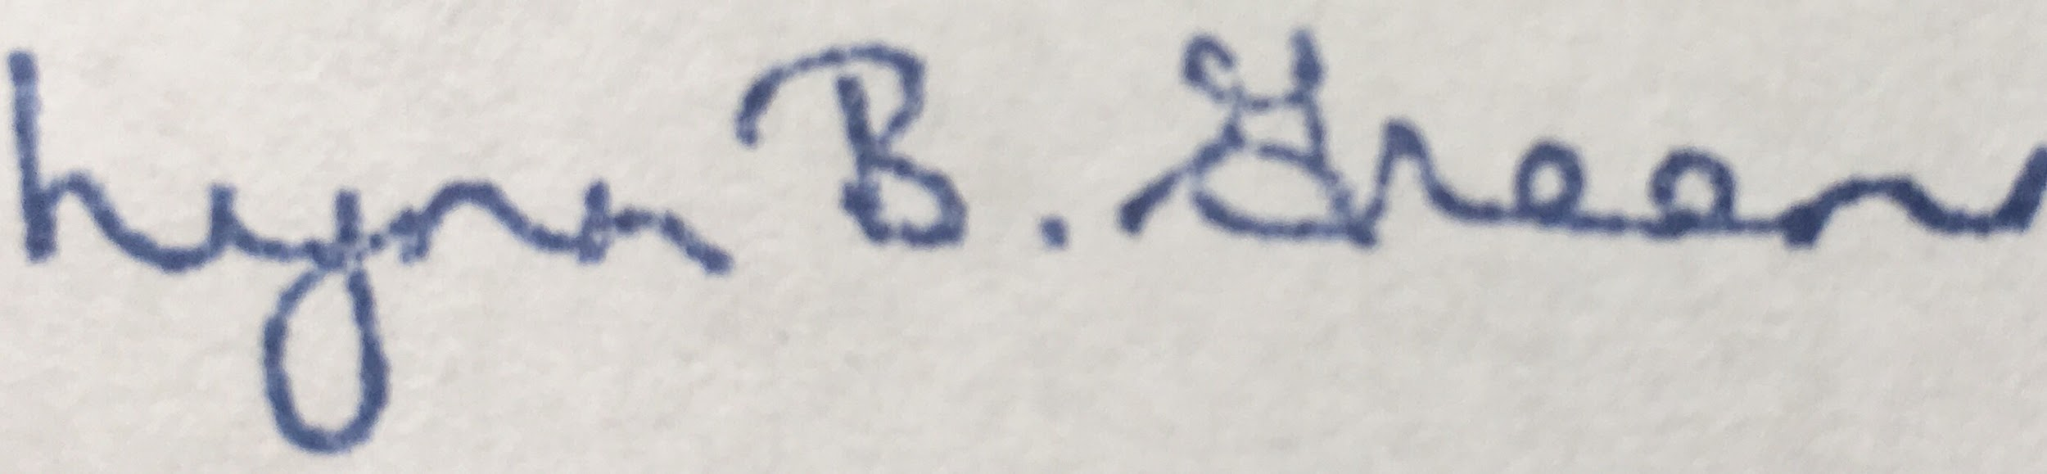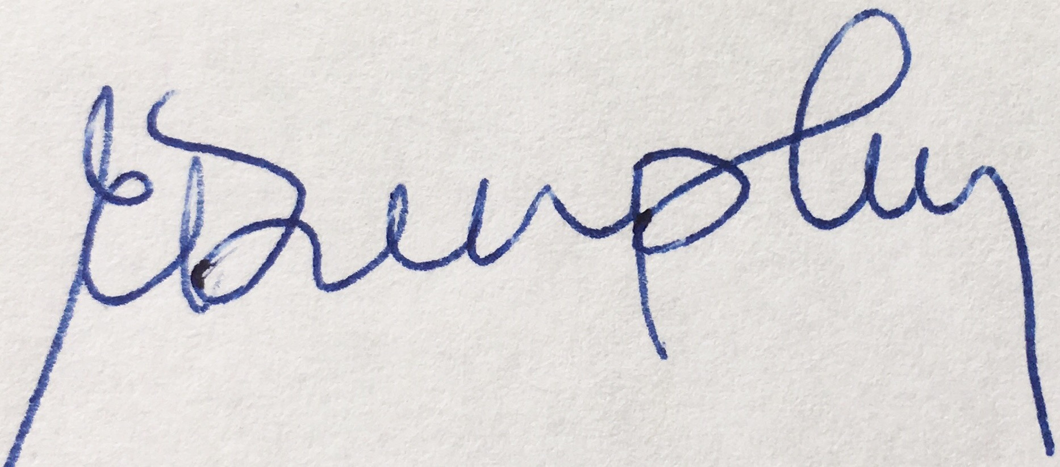
Lynn Green Edie Dunphy
Chair of the Board of Directors Executive Director

